This a brief guide to how install the Minerva Software. Follow these procedures by the given order to the end.

1. First of all you need to enter the website: www.dolly-soft.com
- Press download Setup
- There is some setup file you need to download:
    - Minerva 2018 FULL SETUP
- You need to turn off the windows firewall in the control panel, and in the user accounts change the user account control settings to never notify.
- When you are done You need to install Minerva 2018 FULL SETUP.exe, it’s a default setup procedure as shown in the pictures below
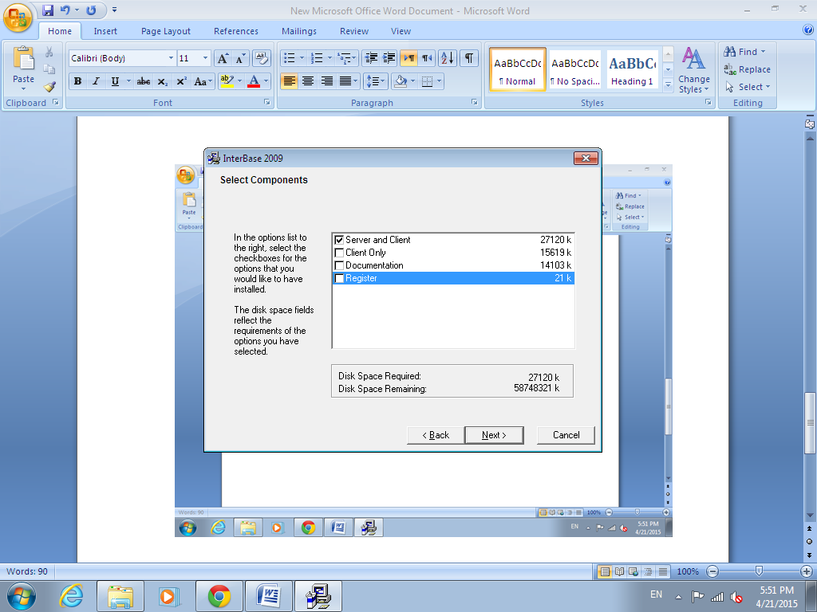
- For more users FOR INTEGRBASE Contact embarcadero.com .
- After the installation is Done, Restart the pc.
3. Launch the program, choose the data to open, by default the data is named, minervan.dol, password=111.
For further questions contact the office and thank you.

