This a brief guide to how install the Minerva Software. Follow this procedures by the given order to the end.

1.First of all you need to enter the website:www.dolly-soft.com, at the bottom of the page as u can see in the picture below
- Press download, you will open the dropbox window.
- There is some setup files you need to download:
    - Minerva full.rar
    - 2009
    - Disk 1 for all windows
- You need to turn off the windows firewall in the control panel, and in the user accounts change the user account control settings to never notify.

- When you are done with that put the minerva folder in any of your drives. You need to install i2009, you open the ib install, it’s a default setup procedure as shown in the pictures below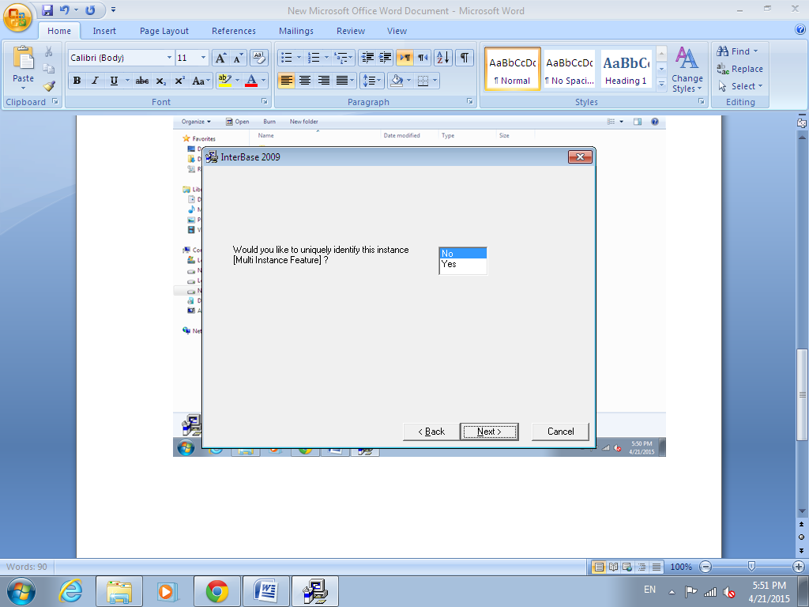
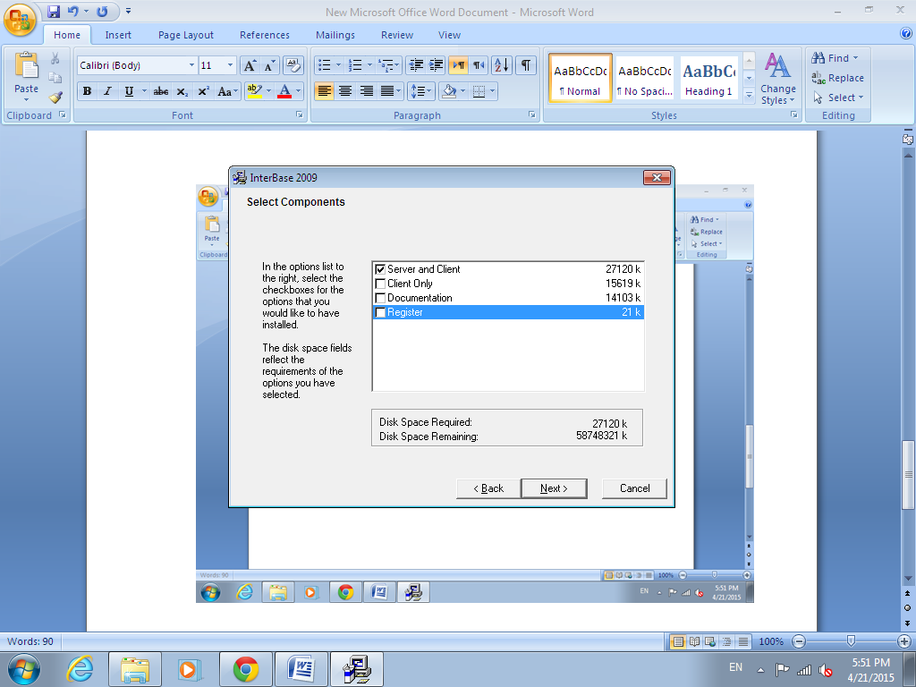
- When your done with the interbase setup, there is the license folder, open it, and launch the license.bat file to complete the setup.
- For more users Contact embarcadero.com .
- Now you need to install the disk 1 all windows, a default setup procedure.
- When you are done with the installation, In the windows startup, In the all programs category you will find a folder named codegear interbase 2009, then launch the interbase server manager, and in the run as windows service press the checkbox. Then press start.
- Now your done with the install procedure, its preferable to restart the pc.
2.After restart go to the place where you putted the minerva full folder, on the minerva_bms application press right click>>properties >>compatibility>>tick the run this program as administrator checkbox.
3.Launch the program, choose the data to open, by default the data is named, minervan.dol, there is no password.
For further questions contact the office and thank you.

